**OLX Technical Assessment**

**South African Telephone Numbers**

Author: Nathanyel Sandi

1. **– Running the application** 
   1. **Setting up local database requirements**

For run the web application is necessary have installed the follow tools in your computer:

* 1. Visual Studio
  2. Microsoft SQL Server
  3. **Running the application though Visual Studio**

Before run the application on Visual Studio, it’s necessary to execute the scripts in order to create database and table to storage data. These scripts are located in the project root folder named as “OLXQueries.sql”, as showed in the follow image:

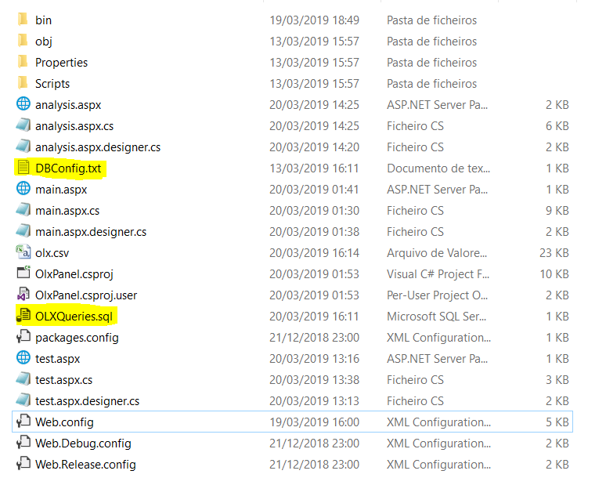

After the execution of these scripts, database and tables will be ready and the next step is setup the connection string in order to connect the application with database. For this operation, there is a txt file named as “DBConfig”, with the configuration of your *local* database server, by default the file has this structure:

|  |
| --- |
| Data Source=localhost;  Initial Catalog=OLX;  User Id=sa;  Password=nathan123; |

If your database is local, after the execution of scripts, just replace the user id and password to yours.

1. **– Functionalities**
   1. **File Upload (main.aspx endpoint)**

**In this endpoint, the user is able to upload the file with the South African Numbers in the right template.**

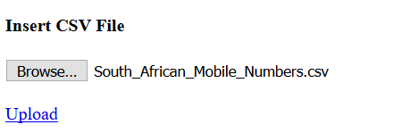

Validation Cases:

|  |  |
| --- | --- |
| **Case** | **Message** |
| **Wrong Format** | Error: Please check database connection or template file. Details: (Error details) |
| **Right format** | The file update is not in the right format (.csv) |
| **Database Error** | Error: Please check database connection or template file. Details: (Error details) |
| **No file updated** | No file updated! |

* 1. **Analysis (analysis.aspx)**

**In this screen is possible to see the analysis of the files uploaded and also download the result of numbers processed by the user.**

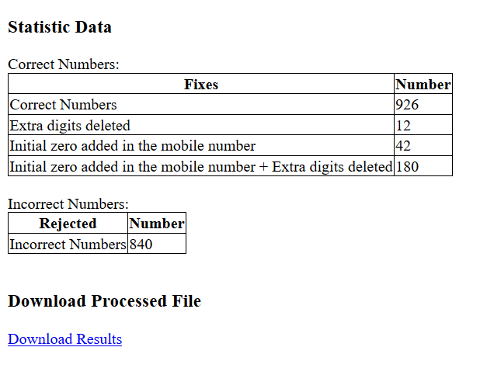

* 1. **Test endpoint (test.aspx)**

**In this endpoint, the user is able to test a single telephone number, and as output, user receives a message that is described in the validation cases. The follow image is showing the screen that is expected accessing this endpoint.**

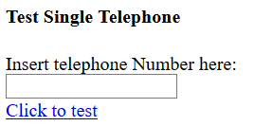

Validation Cases:

|  |  |
| --- | --- |
| **Case** | **Message** |
| **Wrong Format** | The format is wrong. |
| **Right format** | The format is Correct. |
| **With fixes** | The telephone is not right, the error is: Extra digits deleted. After apply a fix, the corrected number is: 27832762842 |

Test Examples:

|  |  |
| --- | --- |
| **Input** | **Output expected** |
| 27832762842 | The format is correct |
| 278327628420 | The telephone is not right, the error is:Extra digits deleted. After apply a fix, the corrected number is:27832762842 |
| 323232311 | The format is wrong. |